
SYMBIOSIS INSTITUE OF TECHNOLOGY
(Established under section 3 of the UGC Act 1956) Re-accredited by NAAC with “A” Grade

Name : Aniruddha Pratap Singh
Year: AY 25-29
PRN: 25070122247
Semester: 3

ASSIGNMENT No: 13
TITLE: Write a Java program to perform reading from and writing to a file using file handling operations.
Problem Statement :
Write a Java program to perform reading from and writing to a file using file handling operations.
Theory:
Java provides file handling through the java.io package. Classes such as File, FileReader, FileWriter, BufferedReader, and BufferedWriter are used to perform input and output operations. File handling enables permanent storage and retrieval of application data. Proper exception handling is necessary to manage file-related errors. These concepts are essential for data persistence.

Program :
import java.io.*;

public class FileHandling {

public static void main(String[] args) { try {
// Writing to the file
FileWriter writer = new FileWriter("javafile.txt");

writer.write("WE ARE LEARNING FILE HANDLING\n");
writer.write("This file is created using FileWriter."); writer.close();

System.out.println("Data written successfully.");

// Reading from the file
FileReader reader = new FileReader("javafile.txt"); BufferedReader br = new BufferedReader(reader);

String line;
System.out.println("Contents of this file:"); while ((line = br.readLine()) != null) {
System.out.println(line);
}

br.close(); reader.close();

} catch (IOException e) { System.out.println("Error: " + e.getMessage());
}

}

}

Output :

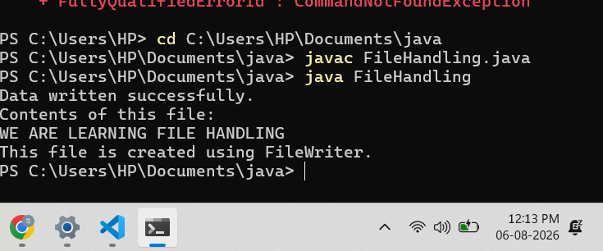

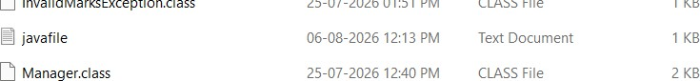

Exercise 1: Create a program to write and read employee details from a file.
Program :

import java.io.*;

public class EmployeeFile {
public static void main(String[] args) { try {
// Writing employee details to file
FileWriter writer = new FileWriter("employee.txt");
writer.write("Employee ID: 101\n"); writer.write("Employee Name: Aniruddha\n")
writer.write("Department: Computer Science\n"); writer.write("Salary: 50000\n");
writer.close();

System.out.println("Employee details written successfully.");
// Reading employee details from file
FileReader reader = new FileReader("employee.txt"); BufferedReader br = new BufferedReader(reader);
String line; System.out.println("\nEmployee Details:"); while ((line = br.readLine()) != null) {
System.out.println(line);
}

br.close(); reader.close();
} catch (IOException e) {

System.out.println("Error: " + e.getMessage());
}
}
}

Output:

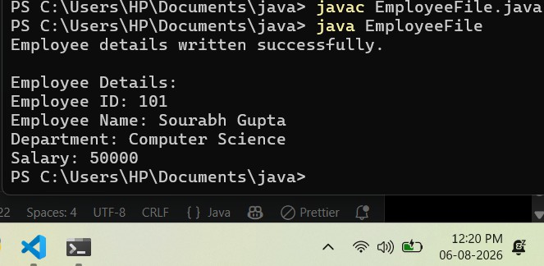

Exercise 2. Develop a Vehicle Insurance System where child insurance classes access parent vehicle information using the super keyword.
Source code:
import java.io.*;

public class PatientFile {
public static void main(String[] args) { try {
// Writing patient details to file
FileWriter writer = new FileWriter("patient.txt");
writer.write("Patient ID: 101\n"); writer.write("Patient Name: Aniruddha\n"); writer.write("Age: 20\n"); writer.write("Diagnosis: Fever\n");

writer.close();
System.out.println("Patient details written successfully.");

// Reading patient details from file
FileReader reader = new FileReader("patient.txt"); BufferedReader br = new BufferedReader(reader);
String line; System.out.println("\nPatient Details:"); while ((line = br.readLine()) != null) {
System.out.println(line);
}
br.close(); reader.close();
} catch (IOException e) { System.out.println("Error: " + e.getMessage());
}
}
}

Output:

